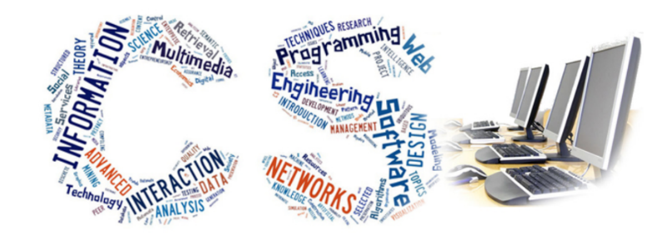

A-Level Computer Science
The exam board we use is OCR and the programming language we code in is Python. You will be able to complete your NEA in any language you want. This link takes you to the exam board specification we are using
https://www.ocr.org.uk/Images/170844-specification-accredited-a-level-gce-computer-science-h446.pdf

For those students who are considering studying Computer Science at A Level, below are some resources to help you get started.

Isaac Computer Science is useful for study notes and understanding the A level specification
https://isaaccomputerscience.org/

We have a membership for Teach ict and this holds some useful websites, quizzes and presentations for A level Computer Science. You will be provided with the membership details once you enrol onto the course. However you are still able to explore the website.
https://www.teach-ict.com/2016/A_Level_Computing/OCR_H446/OCR_H446_home.html

Geeks for geeks can support you with understanding how to program and break the source code down into understandable components
https://www.geeksforgeeks.org/python-programming-language/

Python visualise allows you to enter you source code and it run the code one line at a time to help you understand how the source code is being executed
http://www.pythontutor.com/visualize.html#mode=edit

Dijkstra’s algorithm is one of many we study this website provides useful student friendly facts and information on all the key areas covered in the A level specification.
https://www.tutorialspoint.com/design_and_analysis_of_algorithms/design_and_analysis_of_algorithms_shortest_paths.htm

A fast range of excellent videos to help you understand different computing concepts.
https://student.craigndave.org/a-level-videos

