La transición al español para el año 12.

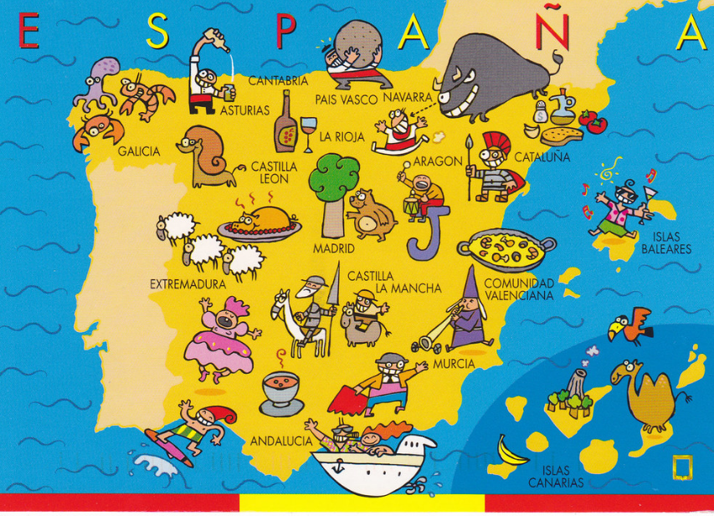

How to prepare for Spanish at A Level
This booklet contains links to a huge range of media, most of which is available for free online as well as tasks to complete before the start of term. In order to keep pace, it is vital that you work through the tasks. Little and often…

Watch…

The news. Click on https://www.rtve.es/noticias/ and then click on Telediario en 4 to watch four minute version of the news. Alternatively you can watch the entire news show which lasts 50 minutes.

FILMS

You won’t study the following films but they are on the specification if you fancy watching them too :
- Ocho Apellidos Vascos (Emilio Martínez Lázaro, 2014)
- María llena eres de gracia (Joshua Marston, 2004)
- Abel (Diego Luna, 2010
- Las 13 Rosas (Emilio Martínez-Lázaro, 2007)

Read…
Keep your own vocabulary book for new expressions you come across. You could order it alphabetically, by topic area based on what we are going to study or just use it as a diary and scribble away your Spanish development in it.

Try using www.lingro.org when reading. You can input the URL and it will make all the words clickable and give an English translation so you don’t have to look up each word in a separate dictionary,

NEWSPAPERS AND MAGAZINES
Read a foreign language newspaper – El País is available in larger paper shops. El País has its own website http://www.elpais.com/ so that you can read the paper online. You do not have to read the paper cover to cover, just scan the headlines and pick out ONE article that grabs your attention.

Websites
Switch to Spanish browsers such as and http://es.yahoo.com/ or www.yahoo.es as well as www.google.es. This way, you will read Spanish every time you log on and it will become part of your everyday activity.

Look at the www.bbc.com/mundo for BBC reporting in Spanish. Click on Videos for clips and reports in Spanish.

For Daily News:
News.yahoo.com/
www.abc.es
www.terra.es

Go to www.donbalon.com for football website and related articles.

Go to www.hola.com for a Spanish celebrity gossip magazine (note that some content requires subscription). This also has short clips in Spanish.

Websites for research
Once you actually start your A Level in September, you will realise that you are almost completing a Sociology A Level in Spanish. It is fascinating and you will learn all about the history and culture of Spanish speakers across the world, not just in Spain.

If you are searching for information, try switching to the Spanish www.es.wikipedia. Remember that anyone can write on Wikipedia so you
must validate your research elsewhere and never quote from it! It is a good place to start though.

British Council support available from http://schoolsonline.britishcouncil.org/

On-line dictionary
Good on-line dictionaries are: http://www.spanishdict.com/
www.linguee.es
www.wordreference.com

As above, this website is very useful: www.lingro.org

TIP When you look up a verb, click the Conjugation tab to see how the verb is conjugated in EVERY tense.

TOP TIP: Don’t look up every word you are not sure of when reading an article/ book

Yes… you read that right. When you are reading articles etc., try not to look up every word as it will take you forever. Skim and scan the text to get the gist. Remember to use the context or the article, cognates and common sense to figure out what the article is saying. Pick out a couple of words that you like the look of, that you feel may be real hurdles to getting the idea of the text, look them up carefully and add them to your vocab booklet. The aim at this stage is to get the gist of the article, not be able to translate it completely. Translation is a whole different ball game and you will learn it soon enough.

You will be surprised how much more enjoyable reading will be if you really pay attention to this tip.

What should I know by now?

This is a common question asked by students about to start their A level. You should be able to:

TOPIC | CONTENT
Recognise and use a range of tenses with regular verbs. | Regular –AR, -ER and -IR verbs:  Tenses:Present  Preterite  Imperfect  Near Future (form of ir + infinitive) Future (eg. Será)  Conditional (eg. sería)
Recognise and use a range of tenses with irregular verbs. | Common irregular verbs: ser, estar, ir, tener, hacer  Tenses: Present  Preterite  Imperfect  Near Future (form of ir + infinitive) Future (eg. Será)  Conditional (eg. sería)
Give opinions with reasons | • A range of opinion expressions  • Positive and negative reasons for opinions  • To be able to agree and disagree

Links to Grammar Practice Exercises •
- Languages on line: The Grammar Revision resources on
www.languagesonline.org.uk are great as you can then select what tense you want to revise, read the explanations and complete the exercises. You can do these as often as you like and it gives you a percentage. Another useful tactic is to translate the examples and exercises into English to ensure you understand the meaning of each tense.h some of the AS Resources.
• Conjuguemos: a great website for practicing your verb conjugations. Find it here: https://conjuguemos.com/k here to access the Spanish verb exercises.

Tasks
Complete the task log, or make your own one up but you will need to go through it with your Spanish teacher in September so make sure that it is clear and useful to you.
When you look at a website/ link on here, highlight it and note the date and what you thought about it. You can then put a couple of notes in your task log.

1. Create a Memrise account if you don’t already have one – your name or something that is very recognisable as you. You should aim to achieve 100,000 points by the first lesson – prizes for those who achieve it! You could start by joining the A-level group. Log into Memrise using your new log in and then click on: https://www.memrise.com/course/1667215/aqa-a-level-spanish-2016-onwards/ to join the group.

2. Summarise, in Spanish, 2 articles (that were in Spanish!) that you have read from one of the websites/ papers above and say why they interested you. If you cannot print the article, make a note of the website. Try and make these related to one of the topics we will study (listed below).

▪ Aspects of Hispanic Society: Modern and traditional values (changes in family, marriage and divorce, influence of the Catholic Church); Cyberspace (influence of the internet, risks and benefits of the internet, smart technology in our society); Equal rights (women at work, Machismo and feminism, LGBT rights)
▪ Multiculturalism in Hispanic Society: Immigration; Racism; Integration
▪ Artistic Culture in the Hispanic World: Modern Day Idols; Spanish regional identity; Cultural Heritage

3. Translate the synopsis for El Laberinto del Fauno before watching it.

Año 1944, posguerra española. Ofelia (Ivana Baquero) y su madre, Carmen (Ariadna Gil), que se encuentra en avanzado estado de gestación, se trasladan a un pequeño pueblo al que ha sido destinado el nuevo marido de Carmen, Vidal (Sergi López), un cruel capitán del ejército franquista por el que la niña no siente ningún afecto. La misión de Vidal es acabar con los últimos miembros de la resistencia republicana que permanecen escondidos en los montes de la zona. Otros personajes son: Mercedes (Maribel Verdú), el ama de llaves, y el médico (Álex Angulo) que se hará cargo del delicado estado de salud de Carmen. Una noche, Ofelia descubre las ruinas de un laberinto, y allí se encuentra con un fauno (Doug Jones), una extraña criatura que le hace una sorprendente revelación: ella es en realidad una princesa, la última de su estirpe, y los suyos la esperan desde hace mucho tiempo. Para poder regresar a su mágico reino, la niña deberá enfrentarse a tres pruebas.

4. Choose a Hispanic country and prepare a short presentation on an aspect of culture (the topics in task 2 may be useful) – this should last no longer than 5 mins. You can create a PPT if you want, but try and use headings rather than too much prose on the slide. This will be good practice for your IRP (Independent Research Project).

5. Look out for any items in the English or Spanish media relating to topics we will study – as above so that you have points to make in a discussion and opinions to give.

6. Go onto www.languagesonline.org.uk . Complete 10 exercises. Each exercise takes less than 5 minutes. Note down the exercise you did and your score.

7. Complete the grammar review (Appendix 1) so that you can target any areas you feel weak on and feel good about the areas you know.

8. Read through the AQA A-Level Spanish course overview so that you have an idea of what we will be studying. This will also help you with task 4 above.
https://filestore.aqa.org.uk/resources/spanish/specifications/AQA-7692-SP-2016.PDF

9. Follow an online Twitter/Instagram feed. See below. If you find any others, note them down.
@Spain - The official Twitter for tourism in Spain
@LaFraseDelDia_ - Más que palabras. A Spanish site which tweets inspirational sayings for each day.
@spanishlanguage – Official Twitter account for Transparent Language Spanish. Learn the language with free resources, social media, and research-based software that works. Tweets expressions, phrases, words and articles in Spanish.
@spanishaddicts – El español de la calle (typical spoken spanish). Esto no son simples traducciones literales, es mucho más que eso. Spanish phrases, vocab, articles and more.
@spanishxxx2 – Free Spanish Sentences Vocabulary Pronunciation Grammar Tests. Tweets vocab, articles, and quizzes.
@muyinteresante – Revista de ciencia, historia, tecnología, salud, psicología, innovación y curiosidades. A Spanish news organisation that tweets in Spanish only. Great for practicing your reading skills.
TOP TIP: Sign up to Twitter and register to a feed that tweets a word or so a day
A word a day is a fantastic way of building your vocabulary. Here are some to choose from:
@SpanishDict - Learn Spanish on the web. Tweets a random Spanish word frequently with the translation.
@VamosSpanish– A word a day goes a long way! Use this online resource to enhance your Spanish learning and ask questions. Tweets words and phrases and translates them. Also tweets other facts and grammar.
@EduLearnSpanish – Learn 3 new words a day on Twitter!
@SpanishWords4U – Spanish Word A Day and computer programs to learn Spanish. Tweets a new Spanish word everyday with example sentences.

